1. **postgre/postgis installation and OSM data import**

The purpose of this document is to present

- how to install postgre sql database and postgis extension

- how to import OSM data into postgre data base

# pgsql install

## install postgre, postgis, pgrouting

1. https://proyectosbeta.net/2018/05/postgis-2-4-en-ubuntu-18-04-lts-bionic-beaver/
2. https://www.howtoinstall.me/ubuntu/18-04/postgresql-10-pgrouting/
3. *apt update*
4. install posgresql, postgis
5. *apt install postgresql-10 postgresql-10-postgis-2.4 postgresql-10-postgis-scripts*
6. install pgrouting
7. *apt install postgresql-10-pgrouting*

## Create super user and db

1. https://docs.postgresql.fr/8.2/app-createuser.html
2. Create superuser
3. *sudo -u postgres createuser -s -P user*
4. Enter password for new role: xxxxx
5. Enter it again: xxxxx
6. Create database
7. *sudo -u postgres createdb -O user db_osm*
8. Open db
9. *psql -h localhost -U user db_osm*
10. Password for user user: xxxxx

## Install phppgadmin

1. https://www.howtoforge.com/tutorial/ubuntu-postgresql-installation/#step-install-postgresql-phppgadmin-and-all-dependencies
2. Configure Apache Web Server
3. *apt install phppgadmin*
4. *cd /etc/apache2/conf-available/*
5. *nano phppgadmin.conf*
6. Configure phpPgAdmin
7. *cd /etc/phppgadmin/*
8. *nano config.inc.php*
9. Find the line '$conf['extra_login_security'] = true;' and change the value to 'false' so you can login to phpPgAdmin with user postgres.
10. restart the PostgreSQL and Apache2 services
11. *systemctl restart postgresql*
12. *systemctl restart apache2*
13. Open phppgadmin
14. <https://www.opentraveller.net/phppgadmin/> or <http://localhost/phppgadmin/>
15. user: user
16. pwd: xxxxx

## Add postgis and pgrouting extension to db

1. Run sql command to osm_db data base
2. > CREATE EXTENSION postgis;
3. > SELECT postgis_full_version();
4. > CREATE EXTENSION pgrouting;
5. > SELECT * FROM pgr_version();
6. Open db
7. *psql -h localhost -U user db_osm*
8. Password for user user: xxxxx
9. *# CREATE EXTENSION postgis;*
10. *# SELECT postgis_full_version();*
11. 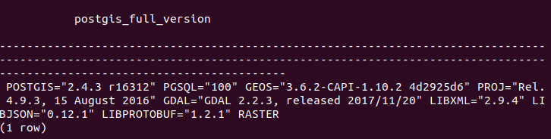

press “q” to quit pgsql answer

press “ctrl+z” to quit sql db

1. *# CREATE EXTENSION pgrouting;*
2. *# SELECT * FROM pgr_version();*
3. 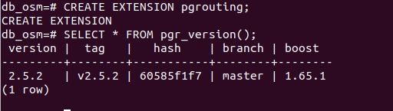

# OSM data import

# Upload osm data

1. Upload osm.bz2 file from <http://download.geofabrik.de/>
2. http://download.geofabrik.de/europe/andorra-latest.osm.bz2
3. *wget -O andorra-latest.osm.bz2 "http://download.geofabrik.de/europe/andorra-latest.osm.bz2"*

## Install osm2pgsql and import osm data into db

1. <http://www.volkerschatz.com/net/osm/osm2pgsql-usage.html>

### Install osm2pgsql

1. *apt-get install osm2pgsql*
2. Import osm data to db_osm db
3. *osm2pgsql --slim -C 100 -d db_osm -U user -W -H localhost -P 5432 andorra-latest.osm.bz2*
4. Password: xxxxx
5. Note it is possible to use .pgpass file so as to avoid to use password in the osm2pgsql line
6. <https://linuxandryan.wordpress.com/2013/03/07/creating-and-using-a-pgpass-file/>
7. *cd ~*
8. *touch .pgpass*
9. *nano .pgpass*
10. localhost:5432:db_osm:user:xxxxx
11. *chmod 0600 .pgpass*
12. *osm2pgsql --slim -C 100 -d db_osm -U user -H localhost -P 5432 andorra-latest.osm.bz2*

Check in phppgsal the db_osm database

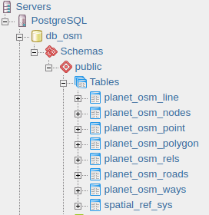

planet_osm_ways: contain all ways with tags

planet_osm_line: contains all imported ways

planet_osm_roads: contains a subset of planet_osm_line suitable for rendering at low zoom levels. planet_osm_line contains too many elements to render on overview maps.

planet_osm_point: contains all imported nodes with tags

planet_osm_rels: contains relation (like rue or hiking route)

<https://wiki.openstreetmap.org/wiki/Relation>

*# Select * FROM planet_osm_ways LIMIT 1*

**

*# Select * FROM planet_osm_nodes WHERE id=3655224911*

